IT24101466 Akeeth W.K.A. Lab 8

1.

2.

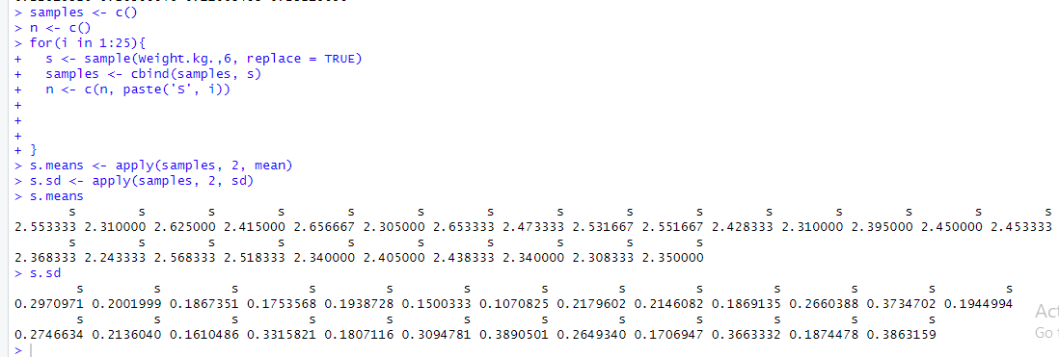

3.

